UNIVERSIDADE FEDERAL DE MINAS GERAIS - UFMG
Faculdade de Letras - FALE
Curso de Especialização em Inglês - CEI

Lídia Rogatto e Silva

English as Second Language to Upper-Intermediate
and Advanced Students

Belo Horizonte
2013
Lídia Rogatto e Silva

English as Second Language to Upper-Intermediate
and Advanced Students

Trabalho de Conclusão de Curso apresentado junto a UFMG – FALE – CEI, como um dos requisitos para a obtenção do título de especialista em Inglês.

Belo Horizonte
2013

To my mother and father
Introduction

The universal importance of the communicative approach to language teaching is attuned to rendering an appropriate method given students’ backgrounds and purposes. Thus, the goal of this approach is to give a step forward in serving the learner’s real communicative needs, in what concerns grammatical, sociolinguistic and strategic competences (Canale and Swain, 1980).
Fulfilling the functions in the target language is only relevant when language needs meet learning needs. In other words, a student’s proficiency corresponds (though not entirely) to the practice of meaningful communication. The relevant emphasis, thus, is on the integration of all four skills by using authentic materials and by giving the learner the role of decision-making.
The two didactic units herein proposed offer meaning-focused activities that engage students to control the transfer of information from one medium (e.g. a text) to another (e.g. a role-play). More importantly, both units were designed to enhance the learners’ competence (Chomsky, 1965) of being the centre of their own learning processes and of practicing English logically and spontaneously.
It is important to state that the two units are independent: while the first is directed to advanced students, the second is suited to upper-intermediate students. They do not differ, however, in terms of age and locus of learning: the public proposed is from 15 years on, contextualized in a private language institute.
Such specificities are justified by the choice of themes. The discussion of body transformation and privacy settings for on-line children are appropriate to a learner that already has some familiarity with English and also that is interested in contemporary subjects – be it by curiosity (as may be the case with most students of the first unit) or by playing an active role of what is being put into question (Internet and privacy).
The different sections contained in each unit are connected to the general topic and are organized in a way so that the four main abilities can be practiced – listening, speaking, reading and writing. Among the features that were taken into account while developing these units were social interaction, creativity and spontaneity.

Note: this material has been developed without commercial purposes and cannot be reproduced with previous consent from the author.
References

Canale, M.; Swain, M. Theoretical bases of communicative approaches to second language teaching and testing. In: Applied Linguistics (1), Oxford University Press, 1-47, 1980.
Chomsky, N. Aspects of the theory of syntax. Cambridge: Cambridge University Press, 1965.

CONTENTS

Introduction..................................................................................................4
Rationale.......................................................................................................7
Unit One: When the Body Wants to Be the Art…………………………..11
Teacher’s guide...........................................................................................20
Unit Two: Children, Internet and Safety……………………………….....25
List of Common Phrasal Verbs………………………………………….35
Teacher’s guide…………………………………………………………...42
Test Booklet…………………………………………………………….....47
Answer key…………………………………………………………..........57
Credits for Unit One and Two………. ……………………….................58

Rationale

The target audience of the two units of this final paper are from 15-years old on. They were developed to offer a communicative learning material for upper-intermediate (first unit) and advanced students (second unit) of a private English institute. The integration of the four skills – i.e. speaking, listening, reading and writing – was a key concern while producing the tasks that prioritize real-world situations. Another concern was to contextualize all the items with the unit’s subject.
The units propose, thus, a functional communication methodology wedded to social interaction activities. In this context, the teacher has the role of generating a linguistic situation, but it is the learner’s responsibility to use the linguistic repertoire he/she has learnt and applying it effectively for specific, immediate needs.
The theme of the first unit – people that transform their bodies in order to obtain a certain ideal – is believed to be an up-to-date, intriguing and thought-provoking subject. Not only it entices students to engage in classroom activities (the photos from the cover are a particular attraction of the unit), but it also renders the group more aware to a contemporary topic. The expected result is preparing students to, outside the classroom, perform what they have learnt (language in use).
This preoccupation also followed the production of the second unit, concerning children and online privacy. A lot has been said about the wonders brought by the Internet, but few English as Second Language textbooks considers the threats that the virtual world poses to one who surfs it inadvertently. The issue gets even more treacherous once the public involved is children. The second unit, then, is a movement towards the questioning of this matter and some of its intricacies.
The Warm-Up section, entitled “Let’s get started!” functions as a motivational brainstorming workout that can add an element of enjoyment and personal involvement while introducing the unit’s topic. Students are asked to get in pairs for the significant goal of exchanging information and points of view. In the first unit, the “correspondence” and speaking activities are designed to stimulate students to reflect upon the cover’s pictures and start a real (though quick) discussion about the topics the unit will cover. The same happens in the second unit, in which learners are stimulated to make connections between some words in a box and then discussing the general subject with a colleague. This pre-teaching section, then, activates student’s schemata, triggers comprehension and improves the integration of the four skills.
In both units, the Listening section is a cognitive-challenging activity that relies upon an audio-visual material – an authentic video from the YouTube website. In the first unit, the true and false questions were designed having in mind that the learner must not only search for information, but also reflect upon what was conveyed and whether the sentences are in accordance with what he/she has watched. In the second, the three questions related to the video test the student’s listening comprehension abilities by a productive skill – writing. In this way, it is possible to evaluate the process of listening by inference.
Tied up with listening in the first unit, an activity on genre follows. This part is particularly connected with the specificities of the video, and in this section the learners can test if their level of attention while watching the video was sufficient for providing the asked list of characteristics. This section is important, then, for two main reasons: 1) the learners force themselves to observe the format and structure of a given material (a movement which they are not always familiarized to); 2) the students feel that all the unit is interconnected.
The phonetics section is only present in the second unit, directed to upper-intermediate students. The task proposed is a pronunciation work in which the students assimilate specific features of connected speech by drawing attention to some forms of phrasal verbs (consonant-consonant, consonant-vowel). The role of the teacher in this task is to facilitate communication by establishing a more precise pronunciation of the words and sentences selected. It is important to note that the teacher must not seek perfection from the student. On the contrary, his responsibility is to establish situations likely to promote communication, whenever they are purposeful. The features of connected speech here studied call the student’s attention to the flow and the changes in the sounds of words. With this short, but important, exercise the learner not only is given clues to speak better, but also to understand native English speakers input more easily.
Speaking is practiced throughout the two units, be it as a warm-up or a task amid other sections (e.g. listening), be it in its particular section (second unit). It is believed that second language learners acquire language when involved in collaboration and interaction with other speakers, native or not (Lightbrown and Spada, 2013). The development of this material follows the concept of providing learners the possibility of acquiring speaking abilities within a variety of environments and for a number of purposes (academic, informal etc.).
The role-play in the second unit follows the principle that the social context of the communicative event is essential in giving meaning to utterances. Moreover, that learning to use language forms appropriately is an important part of communicative competence. This kind of linguistic game (role-play) is relevant because it displays a real communicative event, giving the students a purpose to the exchange – each learner receives immediate feedback from the other – and to the negotiation of meaning.
The pre-reading section of the first unit hinges on two activities in pairs or in trios that, once more, promote better chances of interaction and meaning-negotiation. For many authors – such as Rod Ellis – this is a turning point for the acquisition of a second language (L2). The section motivates students to give their opinions on a specific subject and also to guess, two movements of real-world communication. In this part, the teacher can call student’s attention (and enhance their curiosity on the text they are about to read) while writing on the board some guesses – and, after the reading, to review who got closer to the asked question.
Considering the second unit, the pre-reading section depends on the negotiation of meaning between a picture and a sentence. This kind of task has the potential of engaging students in finding the differences and similarities among texts of different natures (in this case, image and word). The following exercise is a guessing game that integrates reading and speaking, stimulating linguistic production through verbal interaction.
The reading section comprises reading itself, vocabulary practice, comprehension questions and grammar. Once again, all proposed activities are interconnected in a contextualized and meaningful way. The texts chosen (as the video from YouTube) in both units are authentic, and comes from a popular source – the website ABC News for the first unit and BBC News for the second.
- The vocabulary part of both units is a matching exercise that offers students the chance to detect meaning from context and also to increase their lexicon.
- The comprehension questions were designed to activate two “reading horizons” (studied by Luiz Antônio Marcuschi) – the minimum and the maximum. The first one can be explained as depending on a lecture based on paraphrases (identifying objective information that can be translated in other words). The maximum horizon, in which the meanings are gathered by the reunion of information that are in and out of the given text (being, thus, an inference movement) is applied in both units. The exercises in question train comprehensible input without teacher-based instruction.
- The grammar section, for its turn, is inductive and based on the principle of guided discovery – a tool that encourages independence (student’s autonomy) and makes the learning process even more memorable.

Last, but not least, the writing section is a wrap-up of all the skills and discussions practiced before. In the first unit, the competition scheme was designed in order to give students a real, immediate purpose for writing – one of the foundations of the communicative approach. In the second, the magazine article is believed to be a task that puts into question the ability of students to summarize previous materials and convey meaning using their own words, thus practicing a critical mind (in assembling all that has been discussed) and originality (by adding their own point of views).
In conclusion, the didactic units were produced with the aim of effectively putting into practice language in a real context. Validity, practicality and reliability were principles that directed the creation of this material.

References
Dell’Isola, R. L. P. Horizontes de Leitura. Belo Horizonte: Editora FALE/UFMG, 2005.
Ellis, R. Learning a Second Language Through Interaction. Amsterdam: John Benjamins, 1999.
Hinkel, E. Teaching Grammar in Writing Classes. Washington: Seattle University, 2002.
Lightbown, P. M., Spada, N. How Languages are Learned. Oxford: Oxford University Press, 2013.
Littlewood, W. Communicative Language Teaching. Cambridge: Cambridge University Press, 1981.
Neves, M. S. The Communicative Teaching of English as a Foreign Language. Belo Horizonte: UFMG, 1983.

UNIT ONE


WHEN THE
body


Wants to be the art



LET’S GET STARTED!
Have you ever heard of Zombie Boy, real-world Barbie, “Thirty-Two Kilos” photos or The Alternative Limb Project? This Unit is about people who transform their bodies in order to attain a certain ideal.

Together, observe the pictures and try to describe the looks and styles of the people you see. With your peer, try to guess what words may correspond to Zombie Boy (Z), real-world Barbie (B), “Thirty-Two Kilos” model (T), to The Limb Project (P) or to all (A).
Get in pairs.

( ) plastic surgery
( ) underground fashion icon
( ) ideal of physical perfection
( ) tattoo design
( ) body modification
( ) exaggerated limbs
( ) intention to restore/create beauty
( ) starvation and weight-loss
( ) personalized (artificial) body parts as works of art
( ) high fashion and/or anorexia
( ) real-life zombie

In-class discussion.
With your classmates and your teacher’s guidance, exchange ideas about the following questions:
- In what way do you think the people in the photos are different from one another?
- In your opinion, do they share something in common (physically or not)?

LISTENING
Watch the following video. Mark with an X the correct statements:
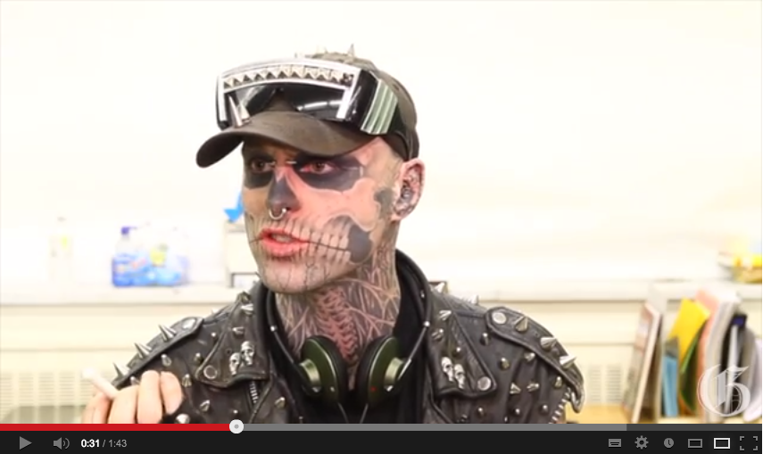
Link for the video: http://www.youtube.com/watch?v=LUSgUfNmKws

( ) In Rick Genet’s opinion, everyone has been judged of being different.
( ) He is visiting a school to make a movie on anti-bullying.
( ) Addressing bullying is an important step in the creation of a better environment and in the construction of a better self-esteem and tolerance.
( ) In the school board, Zombie Boy writes that there is a close connection between bullying and suicide.

REMEMBERING GENRE
Genre is any written, spoken, audial or visual category that follows some set of criteria. Examples of genre are the still life (in visual arts), the short story (in literature), the Western (in films), the hard-rock (in music) and the speech (in speaking).

The video you just saw can be considered a “behind the scenes”/”making of” excerpt of a publicity for anti-bullying. Watch it one more time and compose a list of three or more characteristics that could define this video as a “behind the scenes” genre.
Get in pairs.

PRE-READING
In pairs or in trios.
Do you think that a “Barbie” is an example of beauty? Discuss why.


This is a photo of a real woman and you’re going to read a text about her. What kind of details do you think the text is going to stress?

READING
The Real-Life Ukranian Barbie Doll
NEW YORK, ABC News Radio, 2012 [Abridged]

With a teeny waist, disproportionately large breasts and wide, icy-blue eyes, 21-year-old Valeria Lukyanova says she is the real natural deal. A real-life Barbie, that is.
That’s what she claims anyway. Many are crying foul to her claims of her au natural Mattel-branded looks. Whether she underwent plastic surgery or uses Photoshop to carve out that waist remains unclear.

If she is real and does not use Photoshop on her photos, she likely underwent a barrage of plastic surgery. Dr. Malcolm Roth, president of the American Society of Plastic Surgeons, said plastic surgery should never be used to transform oneself into a favorite celebrity or, in this case, a play toy.
“We believe evaluating any and all issues that may affect our patients’ well-being, including psychological factors, is part of providing total patient care,” Roth said in a statement. “Additionally, Valeria is also only 21, so certain milestones in growth and physical maturity ought to be considered before plastic surgery is performed. ASPS cautions patients to keep in mind that plastic surgery is real surgery with real risks, just as with any operation, so the decision should not be taken lightly.”
Whether Lukyanova is real or fake, Photoshopped or plastic surgery, Diane Levin, professor of Education at Wheelock College in Boston, said the mystery of her existence is not the issue. The problem is that her flaunted image epitomizes and exemplifies the issue of objectification of women in today’s society.
While Lukyanova is an extreme example of societal expectations of perfect beauty, Levin said, “If society expects women to look like that, it is harder for almost any woman to totally resist it.
“This just feeds into our media screen culture, where being involved with real things are becoming more and more removed for children,” Levin said. “Even if she’s totally Photoshopped, the fact that her body is being changed to one that no one actually can attain epitomizes what is happening in our society.”
Levin encouraged parents to have an open discussion with their children about sexualization and objectification in the media. “Rather than just writing it off as someone or something that is ridiculous, allow your child to share your thoughts and have an open discussion about healthy self-image and expectations for themselves and others,” she said.
VOCABULARY
The words from the left are the underlined terms from the text. Go back to them, try to understand their meaning from context, and then match them with the synonyms on the right.

To carve out Public

Barrage Show-off

Flaunted To create with effort

To epitomize Avalanche

Societal To encourage the growth of

To write it off To be a perfect example

To feed into To dismiss it as insignificant

COMPREHENSION QUESTIONS

- According to the text, what is the polemic involving Valeria Lukyanova? Use your own words.
- In what way it is possible to say that Valeria Lukyanova “exemplifies the issue of objectification”?

- Consider Diane Levin’s words in the last four paragraphs and the Zombie Boy video. If you had a child, what topics would you consider important in order to engage in a discussion about his/her self-image?

GRAMMAR
Look back at the following extracts from the text and pay close attention to the underlined words, known as subordinating conjunctions.
Whether she underwent plastic surgery or uses Photoshop to carve out that waist remains unclear.
If she is real and does not use Photoshop on her photos, she likely underwent a barrage of plastic surgery.

While Lukyanova is an extreme example of societal expectations of perfect beauty, Levin said, “If society expects women to look like that, it is harder for almost any woman to totally resist it.

Even if she’s totally Photoshopped, the fact that her body is being changed to one that no one actually can attain epitomizes what is happening in our society.
Rather than just writing it off as someone or something that is ridiculous, allow your child to share your thoughts.
1. Observe carefully the sentences above and select the right answer.
1. 1) “Whether” expresses an idea of:
- doubt
- simultaneity
- addition
1. 2) “Even if” may indicate:
a) an independent idea in contrast to another fact
b) a dependent idea in regard to another
c) a cause-effect situation

1.3) The only conjunction that does not share a similar meaning as “while” in the context of the sentence of the text is:
- although
- in spite of the fact that
- whereas
1.4) “Rather than” has a similar meaning as the conjunction:
a) nevertheless
b) instead of
c) in addition

2. Fill in the blanks with the appropriate connective:

a) __________ (if / while) some people may find his looks monstrous, Zombie Boy (Rick Genet) is described in interviews as being polite and tender.
b) __________ (whether/ while) Valeria Lukyanova represents a paradigm on beauty that will be followed by society, only time will tell.
c) __________ (rather than / even if) merely exposing himself to the media as a thoroughly tattooed underground model, Zombie Boy is an active anti-bullying spokesman.

WRITING
The website Essays on Art is promoting a competition concerning body, media, art and today’s world. In order to participate, you must write a five-paragraph essay in which you correlate the ideas developed by this Unit. The competition’s writing subject is:

“Today, the concept of beauty reflects a cultural transformation that renders us more and more distant from the reality of our bodies”

By this point, you have already read about Valeria Lukyanova (the real-world Barbie) and watched a video displaying Rick Genet (the Zombie Boy). Now take a look at the following two boxes and pictures, about The Alternative Limb Project and the “Thirty-Two Kilos” photos. These may help you in writing your essay for the competition.
Make sure you use the subordinating conjunctions you have learnt at the Grammar section when you wish to connect ideas. Remember also to the read the guidelines about an essay’s specificities at the end. Good luck!

1. The Alternative Limb Project
The Alternative Limb Project offers a personal and friendly bespoke service, which provides unique prosthetics to blend in with the body or stand out as a unique piece of art, reflecting the wearer’s imagination, personality and interests. An alternative-style limb can help to break down social barriers, delight the eye and provide an unusual talking point.




2. The “Thirty-Two Kilos” photographs

Ivonne Thein’s “Thirty-Two Kilos” (or 70 Pounds) are photographs of terrifyingly thin, bandage-wrapped models in fashion editorial poses. Thein highlights the relationship between high fashion and anorexia. Thein, a 30-year-old German photographer, decided to create the series of fourteen photographs after reading about the internet movement “pro-ana” (or pro-anorexia). Pro-ana followers argue that anorexia is a lifestyle choice and provide support and encouragement for one another’s starvation and weight-loss. Thein’s work is a commentary on the pathological striving of young men and women to be extremely thin.




Quick guidelines• for writing an essay:
Essay outline | Paragraphs - Purposes
Introduction | Guide the reader, identify the focus, outline scope, state thesis
Body | Topic sentence 1: supporting details, concluding sentence 1.  Topic sentence 2: supporting details, concluding sentence 2.  Topic sentence 3: supporting details, concluding sentence 3.
Conclusion | Restate thesis, summarise argument.

•For more details, access http://www.study-zilla.com/writing-a-thematic-essay/.

Teacher’s Guide

Unit One

TEACHER’S GUIDE
Unit One – When The Body Wants to be the Art

This Unit is about people who transform their bodies in order to obtain a certain ideal. The lesson plan hinges on topics like beauty, art, media and contemporary ways of life. It is a Unit developed for advanced students and, as such, proposes a thorough discussion on the topic.

Let’s get started!
Get the students to observe the cover of the Unit in pairs. Ask them to observe the pictures and make a descriptive exercise. Whenever needed, help them with precise doubts of vocabulary. Your aid can also be requested to the guessing/association game, with words such as “limbs” and “starvation” probably being unfamiliar to them. If this happens, remember to not translate the words to their mother tongue (Portuguese), but explain them in English – if possible by referring to the pictures while explaining the terms. Give students 3 to 4 minutes to carry on this discussion.

Possible answer key to the guessing/association game:
Z: underground fashion icon, tattoo design, body modification, intention to restore/create beauty, real-life zombie
B: plastic surgery, ideal of physical perfection, body modification, intention to restore/create beauty, high fashion and/or anorexia
T: ideal of physical perfection, intention to restore/create beauty, starvation and weight-loss, high fashion and/or anorexia
P: body modification, exaggerated limbs, intention to restore/create beauty, personalized (artificial) body parts as works of art

In-class discussion: conduct the class to exchange ideas concerning the two questions proposed in the Unit. Stimulate participation of all students. Engage them in conversation by asking their opinion, or if they agree with a colleague’s point of view.

Listening
Tell your students they are about to watch a YouTube video of someone who appeared on the Unit’s cover and who got really famous for his body transformation. Have them read the statements and clarify whatever doubts they might have. You may also tell them not to worry about understanding each and every word, but comprehending the message as a whole. Play the video twice and suggest them to take notes, if necessary.

Answer key
The right answers are 1 and 3.

Remembering Genre
In this part, students will take about 5 minutes to remember the most important characteristics of genre in order to be able to do the following activity. Read the headline with them and move from table to table to see if all pairs and trios are working together and also to clear whatever doubt they might have.

Possible answer key
- It is possible to see the staff (e.g. the camera man) of the video’s production
- Rick Genet is being interviewed “behind the scenes”
- The video is not the anti-bullying publicity itself, but a compilation of different moments of the shooting

Pre-reading
Get students in pairs or trios and advise them to take a close look of the picture. Ask them if they remember the lady from the cover, and if they think she is an example of beauty.
This pre-reading section should stimulate students to guess what kind of meaning the text will convey and what topics will be mobilized for the discussion. Thus, the purpose of this part is to elicit from students what they already know about the picture or what kind of guesses they are able to do.

Reading
Have the students to read carefully the presented text. Remember to infer that if they come across a word or expression they are not familiar with, they should try to get their meaning by context. The reading’s purpose is to comprehend the message as a whole.

Vocabulary
This individual activity exercises synonyms. Should there be any question vocabulary-related, have the students to go back to the text and work out the meaning by context. Optional: Correct the matching exercise with them and ask each student to make a sentence with a term from the left side.

Answer key
To carve out: to create with effort
Barrage: avalanche
Flaunted: show-off
To epitomize: to be a perfect example
Societal: public
To write it off: to dismiss it as insignificant
To feed into: to encourage the growth of

Comprehension questions
Read the questions aloud, asking the students if they understood what they are being asked to reply.

Answer key
- In brief, the polemic is whether Valeria Lukyanova have gone through body modifications (plastic surgeries) and Photoshop.
- Valeria Lukyanova exemplifies the issue of objectification because her image raises discussions related to self-image and societal expectations.
- Open question. Answers may vary.

Grammar
Follow the guidelines contained in the Unit. Remember to call attention to the underlined terms in the box and help students with any doubt they may have concerning the meaning of such terms. Optional: ask students to tell you if they remember any subordinating conjunction that are not present in the Unit’s grammar section. You can write them on the board, make sure everybody are familiar with them and then suggest students to copy the conjunctions (with meaning) in their notebooks.

Answer key
  - A
  - B
  - B
  - B

2) a) while
b) Whether
c) Rather than

Writing
Read the essay’s headlines and the texts with your students. In this section, they will be asked to write an essay relating the topics they discussed in the Unit – media, beauty, art, body – with the two boxes containing information still original to them: the Alternative Limb Project and the Thirty-Two Kilos photographs. Optional: Check text comprehension by asking them specific questions of each box. If you have time, you can divide the class into two groups and get the students to make a list of at least four keywords that synthesize the text they’ve just read. This will also aid them when writing the essay.

UNIT TWO
2
1



CHILDREN, INTERNET AND SAFETY



3
4
LET’S GET STARTED!

1. Read the words in the box below. In what ways do you think they can be related? In pairs or groups of three, have a chat connecting at least four of the words contained in the box. Make sure to write down some of the key points of your discussion and share them with your teacher.
Children / privacy / parents / Internet dangers / education /
technology / government

2. Can you think of some dangers of the Internet? Individually, list three that in your opinion offer greater threats and discuss your options with a partner. Below are some examples that can aid you.

Identity theft / bullying / bad eyesight / sexual predators / pornography / insomnia / gossip of you

PRE-READING

1. Go back to the pictures at the cover of this unit and match them with one of the sentences below:

a) “The internet and mobile phones are now part and parcel of young people's everyday lives.”
b) “The campaigners also highlighted previous research which has shown that many teenagers see "sexting" and hard core pornography as "mundane".”
c) “Cyberbullying is a growing and insidious problem.”
d) “Schools need to step in as the issue is something that parents struggle to keep up with.”

2. All four sentences above were taken from the text you are now going to read. But before you do that, try to guess what will be its subject and tone. Share your notes with a partner and justify your opinion.

READING
Internet safety lessons urged for five-year-olds
Judith Burns, BBC News, 5 February 2013

Pupils as young as five should be given lessons in how to use the internet safely, urge campaigners. The call comes amid fears that children are increasingly exposed to online pornography and forced to send indecent images of themselves to others. The charity ChildLine is holding assemblies in every UK primary school to tell children how to stay safe in the digital age. Claire Lilley, of the NSPCC, said: "We are facing an e-safety time bomb." Ms Lilley said online abuse was one of the biggest child protection issues of our time. "Young people tell us they are experiencing all sorts of new forms of abuse on scale never before seen”.
"The internet and mobile phones are now part and parcel of young people's everyday lives. They are the first generation who have never known a world without them. The benefits are huge, both socially and educationally, but so too are the dangers."
ChildLine says its helpline took some 3,745 calls about abuse via the internet and mobile phones last year, with most callers aged between 12 and 15. Some 250 callers said they were being groomed for sex online. There was also a 70% increase in calls about online pornography with 641 calls, some from children as young as 11 years old.
The campaigners also highlighted previous research which has shown that many teenagers see "sexting" and hard core pornography as "mundane", while cyberbullying is a growing and insidious problem. On Monday the Child Exploitation and Online Protection group (CEOP) warned that pedophiles are increasingly forcing children to carry out sexual acts online.
The NSPCC says that schools need to step in as the issue is something that parents struggle to keep up with. It is calling for lessons in all schools on internet safety with young people themselves sharing tips for keeping safe online and more advice for parents on how to talk to their children about the issue - just as they would about being wary of drugs or strangers.
Abridged from: http://www.bbc.co.uk/news/education-21328411

COMPREHENSION QUESTIONS
- Match the underlined words from the text with their correct synonyms:
pupil among
urge cautious
amid complex
issue encourage
groom direct
insidious student
wary matter
- Read the headlines considering the text you have just read and check if they are true (T) or false (F).
- The scale of abuse detailed in the report is not surprising considering the last generations.
- While Internet pornography has been growing amid teenagers, cyberbullying has been decreasing.
- Internet safety is a topic that must be discussed not only by organizations and specialized groups, but also by schools, parents, kids and teenagers.
- According to Claire Lilley, our society is “facing an e-safety time bomb”. With your own words, write down some arguments that support this evidence.

- Can you think of measures (not contained in the text) that are fighting dangers such as bullying and online pornography?

- With a group of three to four students, make up a list of the advantages and disadvantages (or threats) that the Internet may pose to a regular children and teenager. Make sure to put at least five items in each column.

ADVANTAGES | DISADVANTAGES

GRAMMAR AND VOCABULARY PRACTICE
Go back to the text and take a closer look to the highlighted items.
“…forcing children to carry out sexual acts online.”
“…school needs to step in…”
“…the issue is something that parents struggle to keep up with.”

1. Are you familiar to the meaning conveyed by each one of the sentences? State your guesses with a colleague or two and check with your teacher if your answer is close to the dictionary’s meaning.
2. The words in bold all share a structure. They are known as phrasal verbs. Individually, mark true (T) or false (F) to the sentences below:
- A phrasal verb always begins with a verb.
- A phrasal verb can only be followed by an adverb.
- A phrasal verb never requires a direct object (someone/something).

Practice! For the following exercises, you may consult the list of common phrasal verbs located in the end of this unit.
3. Choose the correct preposition to complete each of the following sentences:
- I can’t ______ (put up with/ run out/ pass away) violence in the Internet.
- There are a lot of websites designed to help children to ________ (make up/ carry away/ keep up) the good work.
- If you are not acquainted with certain topic, you can always _________ (look down/ look it up/ look for) online.

4. Complete the phrasal verbs with the correct particles.
a) The volume of the game you’re playing is too loud. Could you turn it ________, please?
b) I would like to try ____ this game before buying it.
c) To be a client in an online store you have to fill _____ a form with your full name, address and other information.

TIP!
Phrasal verbs are better studied when you come across them, for example when reading a text or listening to an interview or song. This way, it is a lot easier to gasp their meaning in a given context (with inference techniques) or to look for the meaning in a dictionary than to memorize many phrasal verbs at once.

PHONETICS
When we speak naturally it is common to pronounce a given word connecting it with the following word. Fluency of speech has a particular rhythm of making words bump into each other, a feature called connected speech. The aspect of linking final consonants and initial vowels can be exemplified by phrasal verbs and the intruding sounds /r/, /w/ and /j/.
Do /w/ up - Lay /j/ up - Go /w/ away - Get /r/ out - Put /r/ on

When a word ends in a consonant sound and it is followed by a word starting with the same or similar sound, the speaker should pronounce that sound once by lengthening or holding the sound. The consonant should not be pronounced twice. Examples:
Best time: “bestime” [bestym]
Good day: “gooday” [gudey]
Understanding how the connected speech works allows you not only to speak better, but also to understand more easily the speech of native English speakers.
Practice!
Check out the list of phrasal verbs in the end of this unit and select at least three phrasal verbs with a consonantal sound followed by a vowel sound. Write down the intrusive sounds they present.

LISTENING
The video below presents an important overview of what parents can do in order to help their children to surf the web safely. Listen to it and answer the following questions.

Link to the video: http://www.youtube.com/watch?v=V-hUHKiVEgc

- “The Daily 2” is a program based in which city of the United States?

- Imagine you are the parent of a son who surfs the web. What kind of information is important to know in what concerns Internet safety for your children?

- Permission from the parents is recommended for what kind of online activities?

SPEAKING
For this activity, get together with another colleague. Together, you will play the roles of two adult friends who have children about the same age. One of the parents – you may give the characters a name – is afraid that his/her son suffers from cyberbullying and is seeking the friend’s advice of what can be done to prevent this to happen. The conversation can be supported by the scheme below. Make sure to adapt it and to use your own words.
Role-play.
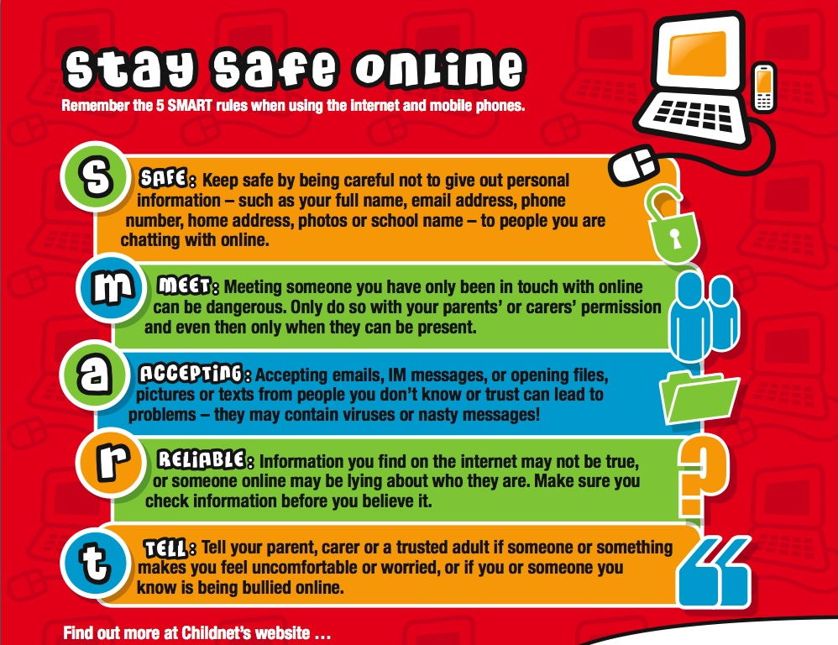

WRITING

Write a magazine article considering the threats of the Internet on children. You may use the text from the Reading section and also the video from the Listening section to help you. However, be sure to use your own words and avoid plagiarism. You can include interviews (imaginary or not) with a kid or a teenager who loves to surf online and also with a worried parent, teacher or expert. Remember to use at least five phrasal verbs. The following topics may be useful while planning what ideas should be included in your article:
- advantages and disadvantages of the Internet
- levels of privacy online
- how can we fight cyberbullying
- gossip on sites like Facebook
- health issues
- what should children learn at school about the Internet
- “e-safety time bomb”

Remembering the writing process!
Before a material such as a magazine article is finally published, the author goes through various stages of writing. Here is a quick guide that may help you. Before you sit down and actually write, consider all the possible information you find relevant. This is called brainstorming. The next step is making brief notes of this material, so you can remember all that you wish before writing the first draft. This stage is a first version of the text you are going to submit, just after revision. In this moment, it is important to make a careful reading and edition of what you have put together. The result of these stages is your text.

List of common Phrasal Verbs
Separable Phrasal Verbs
The object may come after the following phrasal verbs or it may separate the two parts:
- You have to do this paint job over.
- You have to do over this paint job.
When the object of the following phrasal verbs is a pronoun, the two parts of the phrasal verb must be separated:
- You have to do it over.
Verb | Meaning | Example
blow up | explode | The terrorists tried to blow up the railroad station.
bring up | mention a topic | My mother brought up that little matter of my prison record again.
bring up | raise children | It isn't easy to bring up children nowadays.
call off | cancel | They called off this afternoon's meeting
do over | repeat a job | Do this homework over.
fill out | complete a form | Fill out this application form and mail it in.
fill up | fill to capacity | She filled up the grocery cart with free food.
find out | discover | My sister found out that her husband had been planning a surprise party for her.
give away | give something to someone else for free | The filling station was giving away free gas.
give back | return an object | My brother borrowed my car. I have a feeling he's not about to give it back.
hand in | submit something (assignment) | The students handed in their papers and left the room.
hang up | put something on hook or receiver | She hung up the phone before she hung up her clothes.
hold up | delay | I hate to hold up the meeting, but I have to go to the bathroom.
hold up (2) | rob | Three masked gunmen held up the Security Bank this afternoon.
leave out | omit | You left out the part about the police chase down Asylum Avenue.
look over | examine, check | The lawyers looked over the papers carefully before questioning the witness. (They looked them over carefully.)
look up | search in a list | You've misspelled this word again. You'd better look it up.
make up | invent a story or lie | She knew she was in trouble, so she made up a story about going to the movies with her friends.
make out | hear, understand | He was so far away, we really couldn't make out what he was saying.
pick out | choose | There were three men in the line-up. She picked out the guy she thought had stolen her purse.
pick up | lift something off something else | The crane picked up the entire house. (Watch them pick it up.)
point out | call attention to | As we drove through Paris, Francoise pointed out the major historical sites.
put away | save or store | We put away money for our retirement. She put away the cereal boxes.
put off | postpone | We asked the boss to put off the meeting until tomorrow. (Please put it off for another day.)
put on | put clothing on the body | I put on a sweater and a jacket. (I put them on quickly.)
put out | extinguish | The firefighters put out the house fire before it could spread. (They put it out quickly.)
read over | peruse | I read over the homework, but couldn't make any sense of it.
set up | to arrange, begin | My wife set up the living room exactly the way she wanted it. She set it up.
take down | make a written note | These are your instructions. Write them down before you forget.
take off | remove clothing | It was so hot that I had to take off my shirt.
talk over | discuss | We have serious problems here. Let's talk them over like adults.
throw away | discard | That's a lot of money! Don't just throw it away.
try on | put clothing on to see if it fits | She tried on fifteen dresses before she found one she liked.
try out | test | I tried out four cars before I could find one that pleased me.
turn down | lower volume | Your radio is driving me crazy! Please turn it down.
turn down (2) | reject | He applied for a promotion twice this year, but he was turned down both times.
turn up | raise the volume | Grandpa couldn't hear, so he turned up his hearing aid.
turn off | switch off electricity | We turned off the lights before anyone could see us.
turn off (2) | repulse | It was a disgusting movie. It really turned me off.
turn on | switch on the electricity | Turn on the CD player so we can dance.
use up | exhaust, use completely | The gang members used up all the money and went out to rob some more banks.

Inseparable Phrasal Verbs (Transitive)
With the following phrasal verbs, the lexical part of the verb (the part of the phrasal verb that carries the "verb-meaning") cannot be separated from the prepositions (or other parts) that accompany it: "Who will look after my estate when I'm gone?"
Verb | Meaning | Example
call on | ask to recite in class | The teacher called on students in the back row.
call on (2) | visit | The old minister continued to call on his sick parishioners.
get over | recover from sickness or disappointment | I got over the flu, but I don't know if I'll ever get over my broken heart.
go over | review | The students went over the material before the exam. They should have gone over it twice.
go through | use up; consume | They country went through most of its coal reserves in one year. Did he go through all his money already?
look after | take care of | My mother promised to look after my dog while I was gone.
look into | investigate | The police will look into the possibilities of embezzlement.
run across | find by chance | I ran across my old roommate at the college reunion.
run into | meet | Carlos ran into his English professor in the hallway.
take after | resemble | My second son seems to take after his mother.
wait on | serve | It seemed strange to see my old boss wait on tables.

Three-Word Phrasal Verbs (Transitive)
With the following phrasal verbs, you will find three parts: "My brother dropped out of school before he could graduate."
Verb | Meaning | Example
break in on | interrupt (a conversation) | I was talking to Mom on the phone when the operator broke in on our call.
catch up with | keep abreast | After our month-long trip, it was time to catch up with the neighbors and the news around town.
check up on | examine, investigate | The boys promised to check up on the condition of the summer house from time to time.
come up with | to contribute (suggestion, money) | After years of giving nothing, the old parishioner was able to come up with a thousand-dollar donation.
cut down on | curtail (expenses) | We tried to cut down on the money we were spending on entertainment.
drop out of | leave school | I hope none of my students drop out of school this semester.
get along with | have a good relationship with | I found it very hard to get along with my brother when we were young.
get away with | escape blame | Janik cheated on the exam and then tried to get away with it.
get rid of | eliminate | The citizens tried to get rid of their corrupt mayor in the recent election.
get through with | finish | When will you ever get through with that program?
keep up with | maintain pace with | It's hard to keep up with the Joneses when you lose your job!
look forward to | anticipate with pleasure | I always look forward to the beginning of a new semester.
look down on | despise | It's typical of a jingoistic country that the citizens look down on their geographical neighbors.
look in on | visit (somebody) | We were going to look in on my brother-in-law, but he wasn't home.
look out for | be careful, anticipate | Good instructors will look out for early signs of failure in their students
look up to | respect | First-graders really look up to their teachers.
make sure of | verify | Make sure of the student's identity before you let him into the classroom.
put up with | tolerate | The teacher had to put up with a great deal of nonsense from the new students.
run out of | exhaust supply | The runners ran out of energy before the end of the race.
take care of | be responsible for | My oldest sister took care of us younger children after Mom died.
talk back to | answer impolitely | The star player talked back to the coach and was thrown off the team.
think back on | recall | I often think back on my childhood with great pleasure.
walk out on | abandon | Her husband walked out on her and their three children.

Intransitive Phrasal Verbs
The following phrasal verbs are not followed by an object: "Once you leave home, you can never really go back again."
Verb | Meaning | Example
break down | stop functioning | That old Jeep had a tendency to break down just when I needed it the most.
catch on | become popular | Popular songs seem to catch on in California first and then spread eastward.
come back | return to a place | Father promised that we would never come back to this horrible place.
come in | enter | They tried to come in through the back door, but it was locked.
come to | regain consciousness | He was hit on the head very hard, but after several minutes, he started to come to again.
come over | to visit | The children promised to come over, but they never do.
drop by | visit without appointment | We used to just drop by, but they were never home, so we stopped doing that.
eat out | dine in a restaurant | When we visited Paris, we loved eating out in the sidewalk cafes.
get by | survive | Uncle Heine didn't have much money, but he always seemed to get by without borrowing money from relatives.
get up | arise | Grandmother tried to get up, but the couch was too low, and she couldn't make it on her own.
go back | return to a place | It's hard to imagine that we will ever go back to Lithuania.
go on | continue | He would finish one Dickens novel and then just go on to the next.
go on (2) | happen | The cops heard all the noise and stopped to see what was going on.
grow up | get older | Charles grew up to be a lot like his father.
keep away | remain at a distance | The judge warned the stalker to keep away from his victim's home.
keep on (with gerund) | continue with the same | He tried to keep on singing long after his voice was ruined.
pass out | lose consciousness, faint | He had drunk too much; he passed out on the sidewalk outside the bar.
show off | demonstrate haughtily | Whenever he sat down at the piano, we knew he was going to show off.
show up | arrive | Day after day, Efrain showed up for class twenty minutes late.
wake up | arouse from sleep | I woke up when the rooster crowed.

Many of these verbs and definitions are adopted from Grammar Context by Sandra N. Elbaum. Second Edition, Book 2. (Heinle & Heinle Publishers, Boston, 1996.) The examples are from http://grammar.ccc.commnet.edu/grammar/phrasals.htm.

Teacher’s Guide

Unit Two

Teacher’s Guide
Unit Two – Children, Internet and Safety

This Unit proposes the discussion of an extremely contemporary topic, but with a not so common approach: Internet safety, focusing on children. It is a necessary debate in our society since it poses threats that can have severe and undesired consequences not only to kids, but virtually to everyone online.

Let’s get started!
In this section, it is important that the teacher start addressing relevant issues concerning the topic. Read the guidelines aloud with your students and get them in pairs or trios. Be sure to move from group to group during the first activity. The second is to be made individually. Optional: after 3-4 minutes, the teacher can check the activity by proposing students to speak out the list they made up and also compare it with other colleagues. This kind of integration makes the activity more enjoyable to the learner.

Pre-reading
The purpose of this section is to elicit students to activate their schemata and comprehension abilities. Have them read the sentences of the first activity and match them with the correct picture. Remember your students that there is not a complete correspondence between pictured and sentences, but that one picture may be more related to one sentence than another. The importance is in the details.

Answer key
1. a) 1
b) 2
c) 4
d) 3
2. Open question. Answer may vary.

Reading
This authentic text was not created with didactic intentions, but it is rich with possibilities for classroom activity. Get the students to read silently (and individually). Recall that they do not have to worry about unknown vocabulary. On the contrary, tell them to be patient, since they will work with new terms in the next section. Optional: suggest the students to highlight any passage they find important.

Comprehension questions
The comprehension section exercises vocabulary from context (synonyms) and general questions (open and true or false questions) concerning the text. Advise your students to read twice each guideline.

Answer key
- Pupil – student; to urge – to encourage; amid – among; issue – matter; to groom – to direct; insidious – complex; wary – cautious.
- F – F – T
- An “e-safety time bomb” is related to the threats that the virtual world may pose to children, such as abuse, bullying and online pornography.
- Open question. Answer may vary.
- Advantages: good for research, source of hobbies, tool to talk to friends, offers extra material for school, relatively cheap.
Disadvantages: source of procrastination, shows no boundaries to the so-called “adult websites”, imposes threats to those who are unadvised, may keep the children isolated.

Grammar and Vocabulary practice
The grammar section of this Unit is a communicative task based on presenting / remembering phrasal verbs. Read the whole section with the students and solve any question they might have. It is essential to show them the list of phrasal verbs located in the end of the Unit so they can check their guesses and make the proposed exercises.

Answer key
- Open question. Answers may vary.
- T – F – F
- a) put up with
b) keep up
c) look it up
- a) down
b) out
c) out

Phonetics
This part focuses on connected speech. The teacher may read the section’s text with the students and then proceed to the activities. Since this is a phonetics exercise, the teacher should pronounce the words/expressions slowly and clearly. Optional: the teacher can also bring a CD or a YouTube video with connected speech examples from native speakers. This way, the students can have a stronger idea concerning linking sounds.

Listening
This section comprises a YouTube video related to this Unit, in which it is presented an overview of ways to keep children safe while accessing the Internet. The teacher can ask the students to read the questions before they watch the video. After that, the teacher should play the video twice and remember students that it is not important to understand each and every word, but the message of the video (as a whole).

Answer key

The program is based in the city of Atlanta.
- It is recommended that parents leave the computer in an open area, so that their children can be monitored. Also, it is suggested to use parental control features (e.g. Special Block) to restrict what sites they visit, talk about their online activity and teach them the risks.
- Permission is required when children give out their name, address, name of school, phone number and pictures of themselves. Children also must ask their parents’ permission if they want to get together with someone they met online.

Speaking
This section exercises students’ ability to engage in a role-play activity. The teacher must get the students in pairs and explain them that it is important to know very well the role they’ve chosen in order to justify their opinions whenever needed (by the other colleague). Before the role-play itself, have a student or two to read aloud (in class) the five tips contained in the picture and ask them if they have any doubt. Remember to move from pair to pair and to make notes. Optional: give feedback to your students by using your notes and by praising their work and suggesting improvements (if necessary).

Writing
This writing section proposes the students to prepare a magazine article considering the Unit’s topic – Internet’s threats to children. Read the guidelines, topics and clues on the writing process in class and remember them to use at least five phrasal verbs from the list (located in the end of the Unit). Optional: if there is time, you can divide this writing activity by the suggested steps (brainstorming, note-making, draft, revision and conclusion) and give your students feedback on their progress little by little. This way they become aware of the writing stages, more focused on the task and confident at their work.

Test Booklet

The students should be allowed at least 35 minutes to take each test.

Unit 1 Test
Name: Class:
Teacher: Date:
Score: ___/10.0

The discussion of body transformation is surrounded by the idea of beauty. You will now watch a TED presentation by Denis Dutton offering a new perspective on this matter. Remember to take notes while you watch the video. You may use them to answer the questions below.

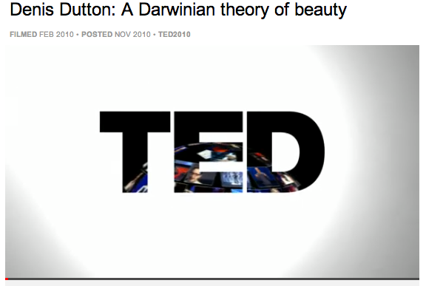
Link: http://www.ted.com/talks/denis_dutton_a_darwinian_theory_of_beauty.html

- Listen to the video’s first 4:10 minutes. Read the following sentences and mark T for true and F for false. (0.4)
a) Denis Dutton’s field of research is biology. ( )
b) Beauty is a complex subject and one of the reasons for this is that we tend to call “beautiful” things with different characteristics. ( )
c) “Reverse engineering” of the artistic taste is a method that helps to explain beauty based on actions and artefacts of our ancestors. ( )
d) According to the speaker, beauty is an evolution trick (a “magnetism”) in a whole series of adaptations studied by Darwin. ( )

- Read the following examples studied by evolutionist theory and decide if they can be explained by natural selection (N) or sexual selection (S). (0.4)
- evolution of tails
- fear
- mating choices
- food-related pleasures

- Denis Dutton gives the example of shell necklaces and ochre body paint in order to: (0.4)
- explicit that artistic and decorative skills are culture-related
- affirm that they came after cave paintings
- express that artistic beauty, just like natural beauty, is not fully cultural
- explain the beginning of arts and crafts fair

- Write a paragraph relating the discussions on body transformation contained in Unit 1 (Zombie Boy, real-word Barbie etc.) to the concept of beauty proposed by Denis Dutton. (1.8)
_______________________________________________________________
_______________________________________________________________
_______________________________________________________________
_______________________________________________________________
_______________________________________________________________
_______________________________________________________________
_______________________________________________________________

- Complete the famous quotes below with the correct subordinating conjunctions from the box: (2.5 – 0.5 each)
Even if / although / whereas / rather than / whether

a) _____________ beauty may be in the eye of the beholder, the feeling of being beautiful exists solely in the mind of the beheld. (Martha Beck)
b) There is more beauty in truth, ______________ it’s a dreadful beauty. (John Steinbeck)
c) Pick a man for his human qualities, his values, his compatibility with you, ________________ what he represents in status, power or good looks. (Edmund Burke)
d) Beauty, _________ moral or natural, is felt, more properly than perceived. (David Hume)
e) _____________ the beautiful is limited, the sublime is limitless. (Immanuel Kant)
- Complete the sentences with one of the correct forms in parentheses. (1.5 – 0.5 each)
_____________(Although / As long as) media claims an image of what we should look like, most of us don’t reach such high standards. _____________ (So that / Still), teenagers continue to try to fit themselves into this image of perfection, ____________ (even though / unless) it comes at a costly price.

- The text below is part of the text “Breaking down the media’s distorted views on beauty”, by Katie Atkinson, a journalist for the Huffington Post. Read it carefully and explain the terms below with your own words. (1.0)
For years, the world of media has been working hard to construct the ideal image of what a "perfect woman" is supposed to look like. […] Magazines, movies, and commercials, among other outlets, have spoon-fed girls with the idea that they can only be beautiful if they have long legs, great hair, and curves in all the right places. […] My question is: why? Why pursue a superficial image that is ultimately unattainable? Why conform to society's distorted standards? […] The image of perfection that today's media presents is nothing but a façade. Girls need to start viewing themselves as more than their bodies. Beauty is more than outer appearance, and it's about time women banded together to knock down the image of perfection society has given us.

Source: http://www.huffingtonpost.com/katie-atkinson/media-beauty-distortion_b_3292467.html

a) Outlet:
b) To spoon-feed:
c) Unattainable:
d) Façade:
e) To band together:
f) To knock down:

- Read some excerpts of the text “Can the media help shift our beauty ideals back in a healthy direction?” (Alice G. Walton, Forbes magazine) and choose the correct alternative. (1.0)
The magazine industry has come under fire in recent years for using too-thin models and for photoshopping them beyond all semblance of reality. In response to public insistence, some magazines have quit using models who are “too thin” or too young, and cut back on digitally altering them. And this may actually have an affect on what we find attractive, according to the new research.
Interestingly, after the participants viewed pictures of very thin or overweight women, their tastes shifted accordingly – so women who viewed pictures of overweight women shifted their preference toward the heavier body type over the course of the study. Oddly, this was true whether the women in the pictures were “aspirational” or plain/unappealing.
It’s important that the images we see be a reflection of health, not simply the average body type. In this way, campaigns that promote ideas like “strong is the new skinny” might be a really helpful tool in swaying our opinions of what’s hot. Hopefully other forms of media – from runway to magazine – will follow suit.

Source: http://www.forbes.com/sites/alicegwalton/2012/11/12/can-the-media-help-shift-our-beauty- ideals-back-in-a-healthy-direction/

- Society’s preference for thinness can be explained by how often we see pictures of thin women in the media.
- Magazines have been using overweight women in their cover in order to participate in the research.
- Women with strong bodies will probably be the next role-models of magazines.
- There is no doubt that media images control what we find attractive.

- In his TED presentation, Denis Dutton declared that the concept of beauty is not entirely based in cultural (and modern) characteristics, but that is traced back to our ancestors and related to biological factors. Reading Walton’s text (above), do you think that Dutton’s assertion can be extended to body attractiveness in our contemporary society? Explain. (1.0)
_______________________________________________________________
_______________________________________________________________
_______________________________________________________________
_______________________________________________________________
_______________________________________________________________
_______________________________________________________________
_______________________________________________________________

Unit 2 Test
Name: Class:
Teacher: Date:
Score: ___/10.0

In our contemporary world the Internet occupies a huge part of our lives, being a facilitator for communication, work and also a source of pleasure. Although it is generally praised for the best, the virtual space also poses some threats. The text below concerns “phishing”, a danger still unknown to many people.

What is phishing?
Phishing is basically someone trying to get you to do something or tell them something through email that enables them to compromise you in some way. This typically works by dangling some kind of bait in front of you. One of the most famous examples of phishing is the Nigerian 419 scams which lured people into giving their bank information with the promise of huge riches.
Other kinds of phishing emails try to convince you to open an attachment or click on a link. These can lead to your computer (or whatever device you read the email on) becoming infected with something nasty. Or it could lead you to unknowingly give a criminal your security credentials for a site. For example, say you receive an email from LinkedIn saying someone wants to connect with you. You click on the link and you get the login page for LinkedIn. Pop your password in and land on the page you expected to be sent to. Everything looks normal and you have no idea that you just gave your LinkedIn password to a criminal.
Phishing that specifically targets you is called "spear phishing." This means the attacker used information they had learned about you – for example from calling the switchboard or looking at your social networking profiles and interactions – and then created an email specifically designed to look highly plausible to you. These emails can be very sophisticated and hard to spot. Why would someone want to target you in this way? Well, perhaps they're actually targeting the organization you work for and you provide a convenient foot-in-the-door. Or perhaps they're ultimately after someone in your network. You never know how tempting a target you might represent to an attacker, so it's important to be vigilant.

Abridged from: http://www.csoonline.com/article/740846/raising-awareness-quickly-a-brief-overview-on-phishing?page=1

- Match the words from the text with their synonyms. (1.8 – 0.3 each)

To enable Unpleasant
Attachment To swing
To dangle Fraud
Scam To allow
Nasty Believable
Plausible File

- Write T (true) or F (false) to the following statements. (1.5 - 0.5 each)
a) Phishing is a virtual threat that happens through e-mail. ( )
b) “Spear phishing” is an e-mail practice designed to get authorized access your to confidential data. ( )
c) Through phishing, one can get you or your contacts to do something compromising. ( )

- The text gives some indirect tips on how to be protected from phishing. Write down at least three of them. (1.0)
_______________________________________________________________
_______________________________________________________________
_______________________________________________________________
_______________________________________________________________
_______________________________________________________________
_______________________________________________________________

- Each of the following sentences contains a phrasal verb. Choose a suitable adverb to fill each gap and complete the structure. A synonym is given in brackets at the end of each statement. (2.0 – 0.4 each)
a) Hackers are extremely creative, they always come _______ with ideas on how to get to your personal information. (create, produce)
b) If have doubts concerning some e-mail in your account, you should look _____ before opening it. (examine)
c) My father called the technical support because his computer broke ______ again. (stopped working)
d) Parents should point _______ to their children the dangers posed by the Internet. (bring attention to)
e) Yesterday I read a newspaper article that brought ______ some tips on Internet safety. (make noticeable)

- Read the strip below and select the correct alternative: (0.5)

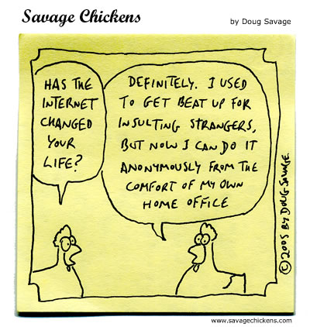
The phenomenon associated with the chicken on the right side of the cartoon is:
- phishing
- cyber-bullying
- spam
- identity theft

- Watch the video below and answer true (T) or false (F) for the assertions below. (1.5 – 0.3 each)
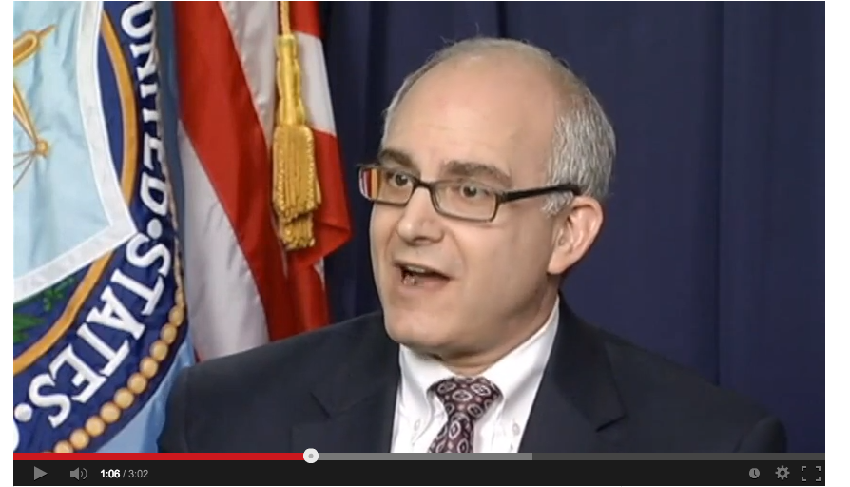

Link: http://www.youtube.com/watch?v=5XpNx11F_20
a) Michael is a rare example of identity theft. ( )
b) Michael had closed his Facebook account on 2008, but his page started running again in 2013. ( )
c) The “likes” on Michael’s hijacked account were related to violence and pornography. ( )
d) It is highly likely that Michael’s account was phished during the 14-day period that follows the deletion process. ( )
e) The FBI’s Internet Crime Complaint (iC3), handled Michael’s case and within hours could find who was responsible for the hijacked account. ( )

- Imagine you have a teenager friend who just created a Facebook account. Write a short paragraph with advices and important information that you think are important to prevent him from Internet threats. Remember to use at least three phrasal verbs contained in the box below. (1.7)
Check (something) out / figure (something) out / find out / go ahead / look into (something) / put up with / set (something) up / show off / think (something) over / try (something) out

_______________________________________________________________
_______________________________________________________________
_______________________________________________________________
_______________________________________________________________
_______________________________________________________________
_______________________________________________________________
_______________________________________________________________

Answer keys

Test Booklet I
Body transformation and beauty

1) a) F
b) T
c) T
d) T

2) a) S
b) N
c) S
d) N

3) C

4) Open question. Answers may vary according to the student.

5) a) although
b) even if
c) rather than
d) whether
e) whereas

6) although / still / even though

7) a) Outlet: a market for products or services
b) To spoon-feed: to treat somebody in a way that discourages independent thought or action
c) Unattainable: not able to be reached
d) Façade: an aspect that conceals a less pleasant reality
e) To band together: to group
f) To knock down: to extinguish, destroy

8) A

9) Open question. Answers may vary.

Test Booklet II
Internet threats and safety

1) to enable – to allow
attachment – file
to dangle – to swing
scam – fraud
nasty – unpleasant
plausible – believable

2) a) T
b) F
c) T

3) Possible answers: protect your information, check the address, don’t click on links, don’t open attachments.

4) a) up
b) over/through
c) down
d) out
e) out

5) B

6) a) F
b) T
c) F
d) T
e) F

7) Open question. Answers may vary.
Credits for Unit One

Related to Zombie Boy
(Cover photo)
http://www.gobeyondthecover.com/images/MZB_MtZmbBy_AbtTtsIMG01.jpg
(Video)
http://www.youtube.com/watch?v=LUSgUfNmKws

Related to Real-world Barbie
(Cover photo)
http://www.play4movie.com/file_fashion/858/gallery/BG_Valeria_Lukyanova_for_V_Magazine%203.jpg
(Photo and text)
http://abcnewsradioonline.com/health-news/the-real-life-ukrainian-barbie-doll.html#ixzz2ZQuPzZyj

Related to The Alternative Limb Project
(Text)
http://www.thealternativelimbproject.com/
(Photos)
http://www.hypeness.com.br/2013/06/as-incriveis-proteses-personalizadas-que-sao-verdadeiras-obras-de-arte/

Related to the “Thirty-Two Kilos” Photos
(Photos)
http://theartreserve.com/ivonne-theins-thirty-two-kilos

Credits for Unit Two

Cover photos
Photo 1:
http://www.heykidsmagazine.com/more-internet-threats-for-children/

Photo 2:
http://content.time.com/time/covers/0,16641,19950703,00.html
Photo 3:
http://www.keepingpacewithkids.org/wp-content/uploads/2011/01/child-internet.jpg
Photo 4:
http://www.opencolleges.edu.au/informed/features/15-strategies-educators-can-use-to-stop-cyberbullying/

Listening: YouTube Video
http://youtu.be/V-hUHKiVEgc

Speaking: Stay Safe Online
(Photo) http://www.jonathansblog.net/files/staying_safe_online_large.jpg

